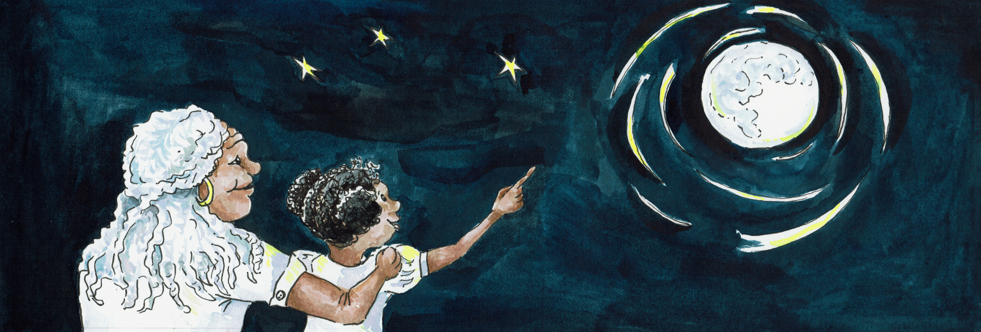
Suggested Age Range: 4 - 5 years; 5 - 6 years; 6 - 7 years; 7- 8 years; 8 - 9 years; 9- 10 years; 10 - 11 years;
Suggested UK Year Group: Year 6
UK Curriculum: KS2;
UK Primary Curriculum Link: Light
Science Subject: Eclipse
Science Question: Why do we have eclipses?
Suggested Science Activity: Eclipses
Children with SEND: Use to boost comprehension of science vocabulary
EAL children: For beginners of English - filmed with subtitles for ease of use
Country of Origin: China
Source: The original tale was shared with Cassandra Wye by the Cantonese community of Birmingham, UK. This eclipse variant is attributed to Hmong people

Long ago, when the world began, according to Chinese legend.
There was one earth, spinning in the sky! There was one moon, spinning in the sky!
But, but, but – was there just one sun – No!

There was … One, Two, Three, Four, Five, Six!
Six suns that rose in the sky above China.
And it was hot! Very, very, very, very, very, very hot!
It was so hot! It was just too hot for any food to grow!
It was just too hot for any water to flow!
What could the people of China do? There was nothing, nothing, nothing they could do!

But, but but …
There was one man, who had a plan! Hao Ai!
“I know what to do! I know what to do! I know what to do!”
“I am the greatest archer in all of China!”
“I can shoot down a bird, from the sky, without even looking!” “Ping! Plop! See!”
“And I will shoot down five of the suns from the sky!!

So, that night, Hao Ai.
He walked and walked and walked and walked away from everyone and everything
He waited for the first sun to appear in the sky.
He lifted his bow. He threaded his arrow. He pulled back the string,
He took aim and fired! Ping! It missed! Plop!“My bow and arrow are just too small!”
“But, but, but am I, Hao A,i going to give up! No!”

So, he tried again!
It took him a whole year! To carve a bigger bow. Carve, carve, carve, carve, carve!
And a bigger arrow! Carve, carve, carve, carve carve! Until there were complete!
That night,
he walked and walked and walked and walked away everyone and everything.
He waited for the first sun to appear in the sky.
He lifted his bow.He threaded his arrow.
He pulled back the string.He took aim and fired! Ping! It missed! Plop!
“My bow and arrow are still too small!” “But, am I going to give up? No!”

So, he tried again.
An even bigger bow! Carve, carve, carve, carve, carve. Ping, plop – missed!
He tried again!
An even bigger bigger bow! Carve, carve, carve, carve, carve! Ping, plop – missed!
He tried again. An even bigger, bigger, bigger bow!
For ten, twenty, thirty, forty, fifty years! Carve, carve, carve, carve, carve !
Until the biggest bow and the biggest arrows were complete!

“I, Hao Ai, am going to shoot down five of the suns from the sky!”
But, but, but nobody, nobody, nobody in China believed him!

“No you can’t!” “Yes I can!” “No you can’t!”“Yes I can!”“No!” Yes!” “No!”
“Yes I can”!

So, that night, Hao Ai.
He walked and walked and walked and walked away from everyone and everything.
He waited for the first sun to appear in the sky. He lifted his bow. He threaded his arrow.
He pulled back the string. He took aim and fired! Ping!
And it went higher and higher and higher and higher, and closer and closer and closer and closer. Until it hit the sun and exploded with a mighty Pong!

“I did it! I did it I shot down a sun!”

But, but, but just then, a man appeared! “Hao Ai what is happening?”
There was an enormous ping and then an enormous pong! And a sun fell out of the sky!

“It is I!” said Hao Ai, “I shot down a sun!”“No!”“Yes!”“No!”“Yes!”
“No! You can’t do that!””Yes I can – and I will do it again!”

So, he waited for the second sun to appear in the sky.
He lifted his bow. He threaded his arrow. He pulled back the string.
He took aim and fired! Ping!
And it went higher and higher and higher and higher, and closer and closer and closer and closer! Until it hit the sun the sun and exploded with a mighty Pong!

“Yes!” said Hao Ai “I did it! I can shoot down a sun!”

But, but, but, people came from here, there, everywhere!
“What is going on? What are are all those pings and pongs?”
And Has Ai said “It is I, Hoa Ai, shooting down the suns!” “No!” “Yes!”
“No!” “Yes I can!”

So, he waited for the third sun to appear in the sky.
He lifted his bow. He threaded his arrow. He pulled back the string.
He took aim and fired! Ping!
And it went higher and higher and higher and higher, and closer and closer and closer and closer, until it hit the sun the Sun and exploded with a mighty Pong!
“I did it I did it I did it! I shot down a sun!”

“Water, please fetch me some water!”
But, but but – of course there was no water:

“Quick we must dig!”Dig, dig, dig
Water! Bucket! Fill bucket! Fill bucket, fill bucket!
Hao Ai – Drink!

“Yes, I can! I can shoot down a sun!”

So, he waited for the forth sun to appear in the sky.
He lifted his bow.He threaded the arrow. He pulled back the string.
He took aim and fired! Ping!
And it went higher and higher and higher and higher, and closer and closer and closer and closer, until it hit the sun the sun and exploded with a mighty Pong!

“Yes” said Hao Ai “I did it!I shot down a sun!”

Hao Yi collapsed to the ground “I can’t do it!”

The people of China, they tried to encourage him
“Yes you can! Hao AI” “I can’t” “You can!” “I can’t”
“Yes, you can!””Come on Hao Ai! Come on Hao Ai! Come on!”

Together, they lifted him up.
And together, they waited for the fifth sun to appear in the sky.
And together, they lifted the bow.Together, they threaded the arrow.
Together, they pulled back the string and together they aimed! Ping!
And it went higher and higher and higher and higher and closer and closer and closer and closer, until it hit the sun and exploded with an almighty Pong!

“Yes, we did it! We shot down a sun!”

And this should be the end of the story…

But, but, but …
The sixth sun, he had seen what had happened to all his brothers!
He didn’t want to die!
The sixth sun rose in the sky, very cautiously, “One. Two. Three”
He saw the bow, he saw the crowd …
No! Hide! Mountain! Hole! Cave!
He rose up and up and up! And down into the cave. And hid!
“I am not coming out for anything!I am not coming out for anything!”

But, but, but …
The sky turned from gold to black, everything was silent.
The birds had stopped singing and a great shadow swept across the land.
And everything was dark, so very, very dark!
The people of China said: “Where is the sun? Where has he gone? We need him!”

They looked, they saw – mountain! They looked, they saw – cave!
They looked they saw – gold! The sun is hiding in the cave in the mountain!
“Sun, sun! Come out, we need you!”
But no sun appeared

“We need, we need someone to call the sun into the sky!”
“Dove – can you call the sun to rise?” “Coo? Me?” “I will try!”
“Coo, coo, coo, coo, coo, coo”
But, but – no sun appeared

“Peacock- you have a louder voice – can you call for the sun to rise?”
“Awhook, awhook, Me? I will try!”
“Awhook, awhook, awhook!”
But, but, but – no sun appeared!

“Rooster, rooster – you have the loudest call of all!”
“Can you call for the sun to rise?” “Cock a doodle doo! Me? I will try!”
Cock a doodle doo! Cock a doodle doo! Cock a doodle doo!

And, and, and the sun heard what the rooster was trying to say!
That it was safe, safe for him to rise in the sky. And so he did! Whoosh!

The sun rose into the sky! And as the sun rose in the sky,
Its’ golden rays fell down – ting! Down onto the Roosters’ head.
And a golden red crown appeared – that he wears to this day
.
And that is why, every day the Rooster calls the sun into the sky!

Cock a Doodle Doo!

And that is also why, every time there is, what we call a solar eclipse, when the sun, and moon and earth are aligned

And the moon hides the sun from our view on Earth,
It is the Rooster that calls the Sun back from into the sky, once again!

“Cock a doodle doo!”

Or at least that is what I was told!

